# Anexo 4 - Fase 4 y 5 - Modelamiento y Evaluación

## CI num_cap

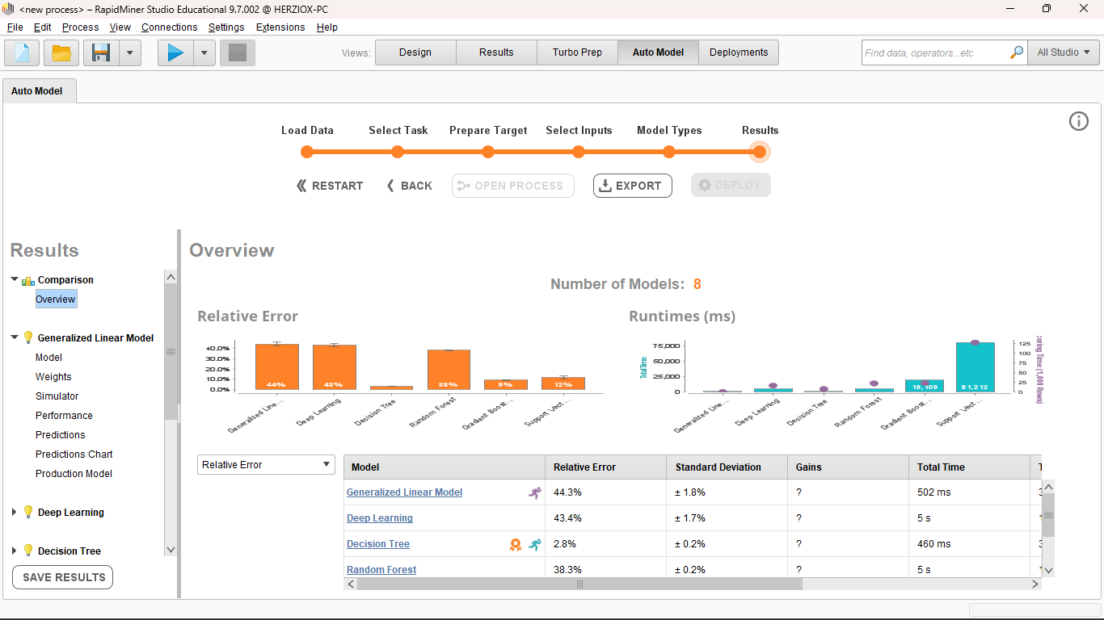

## CI total_horas

## CI Total_ganancias

## CI volumen_Cap

## CI volumen_horas

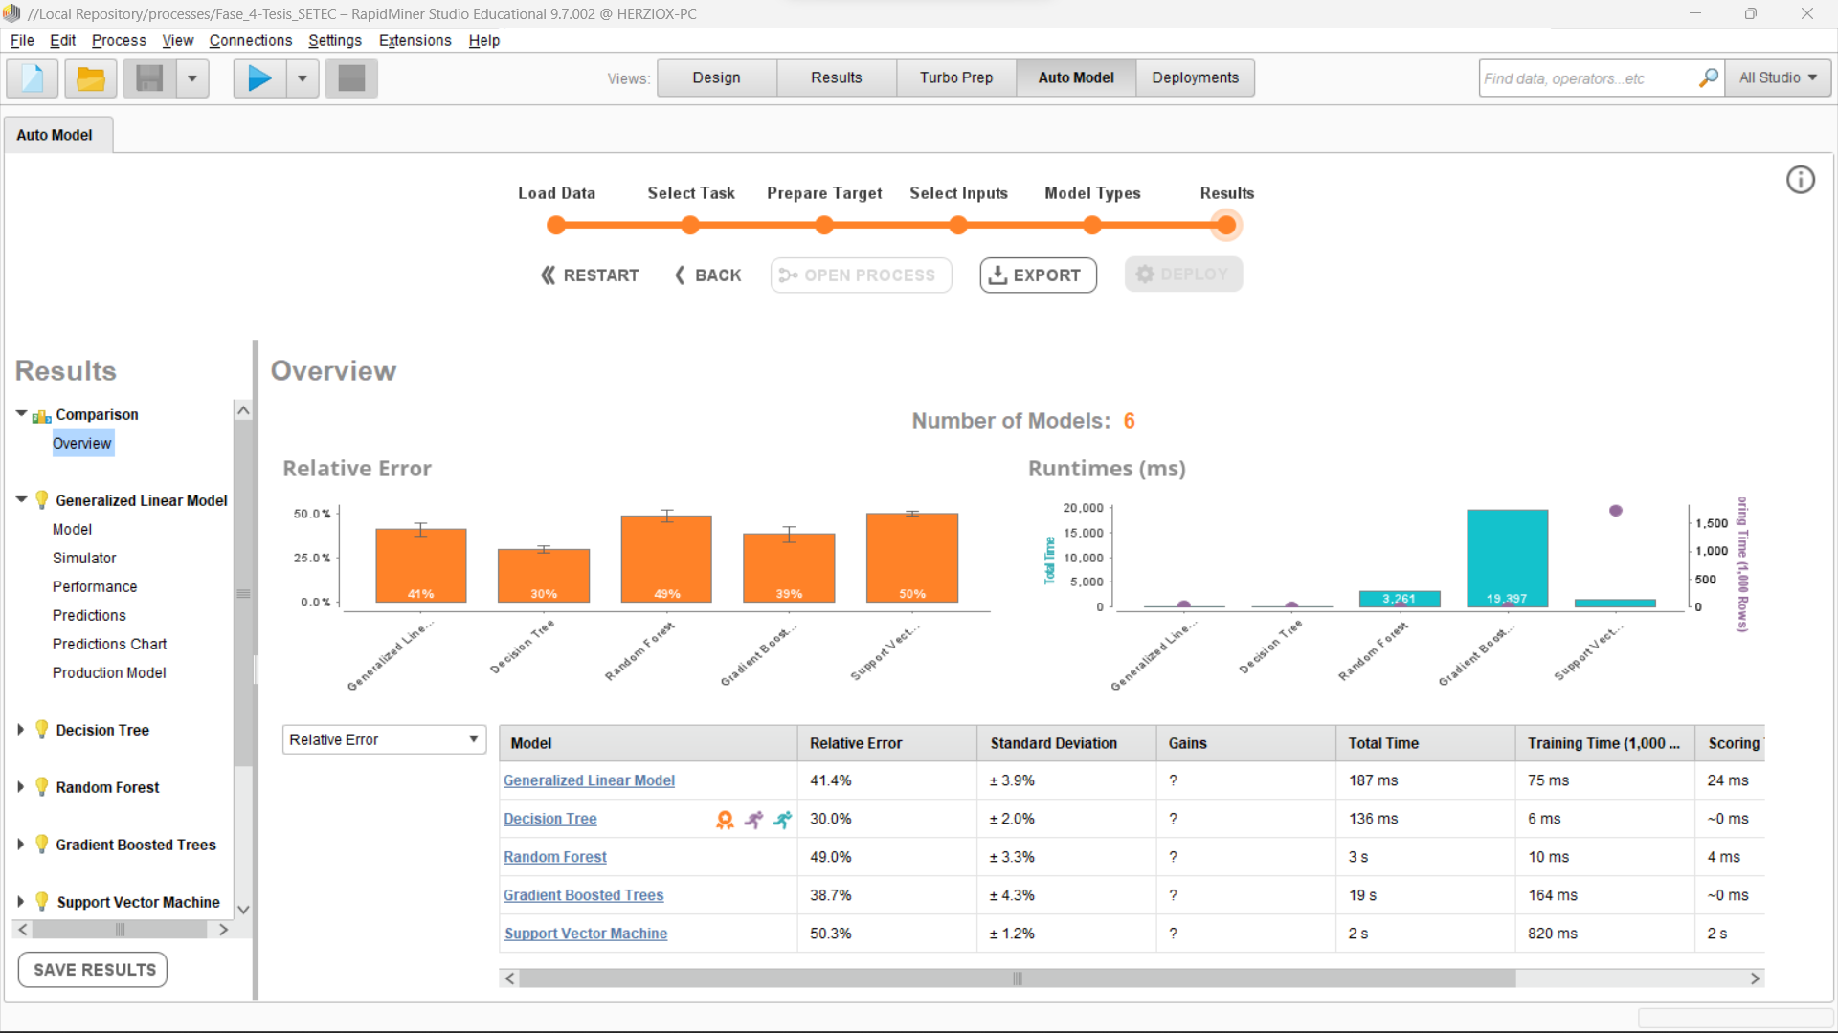

## CI volumen_ganancias

## CI Total_cursos

## OC num_cap_cer

## OC total_horas

## OC Total_Ganacias

## OC porcentaje_asistencia

## OC Volumen_cap_cer

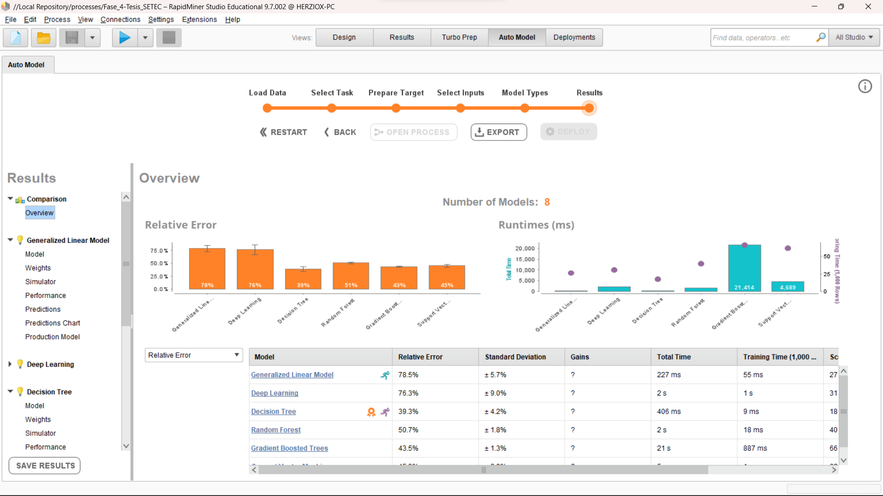

OC volumen_horas

## OC volumen_ganancias

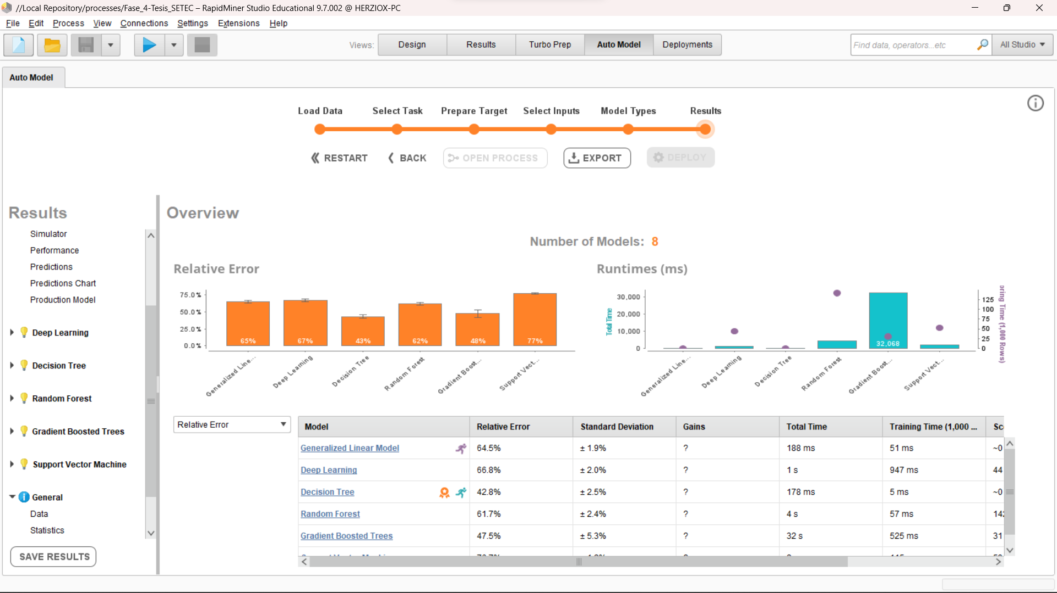

## OC total_cursos

## OC volumen_porcentaje_asistencia

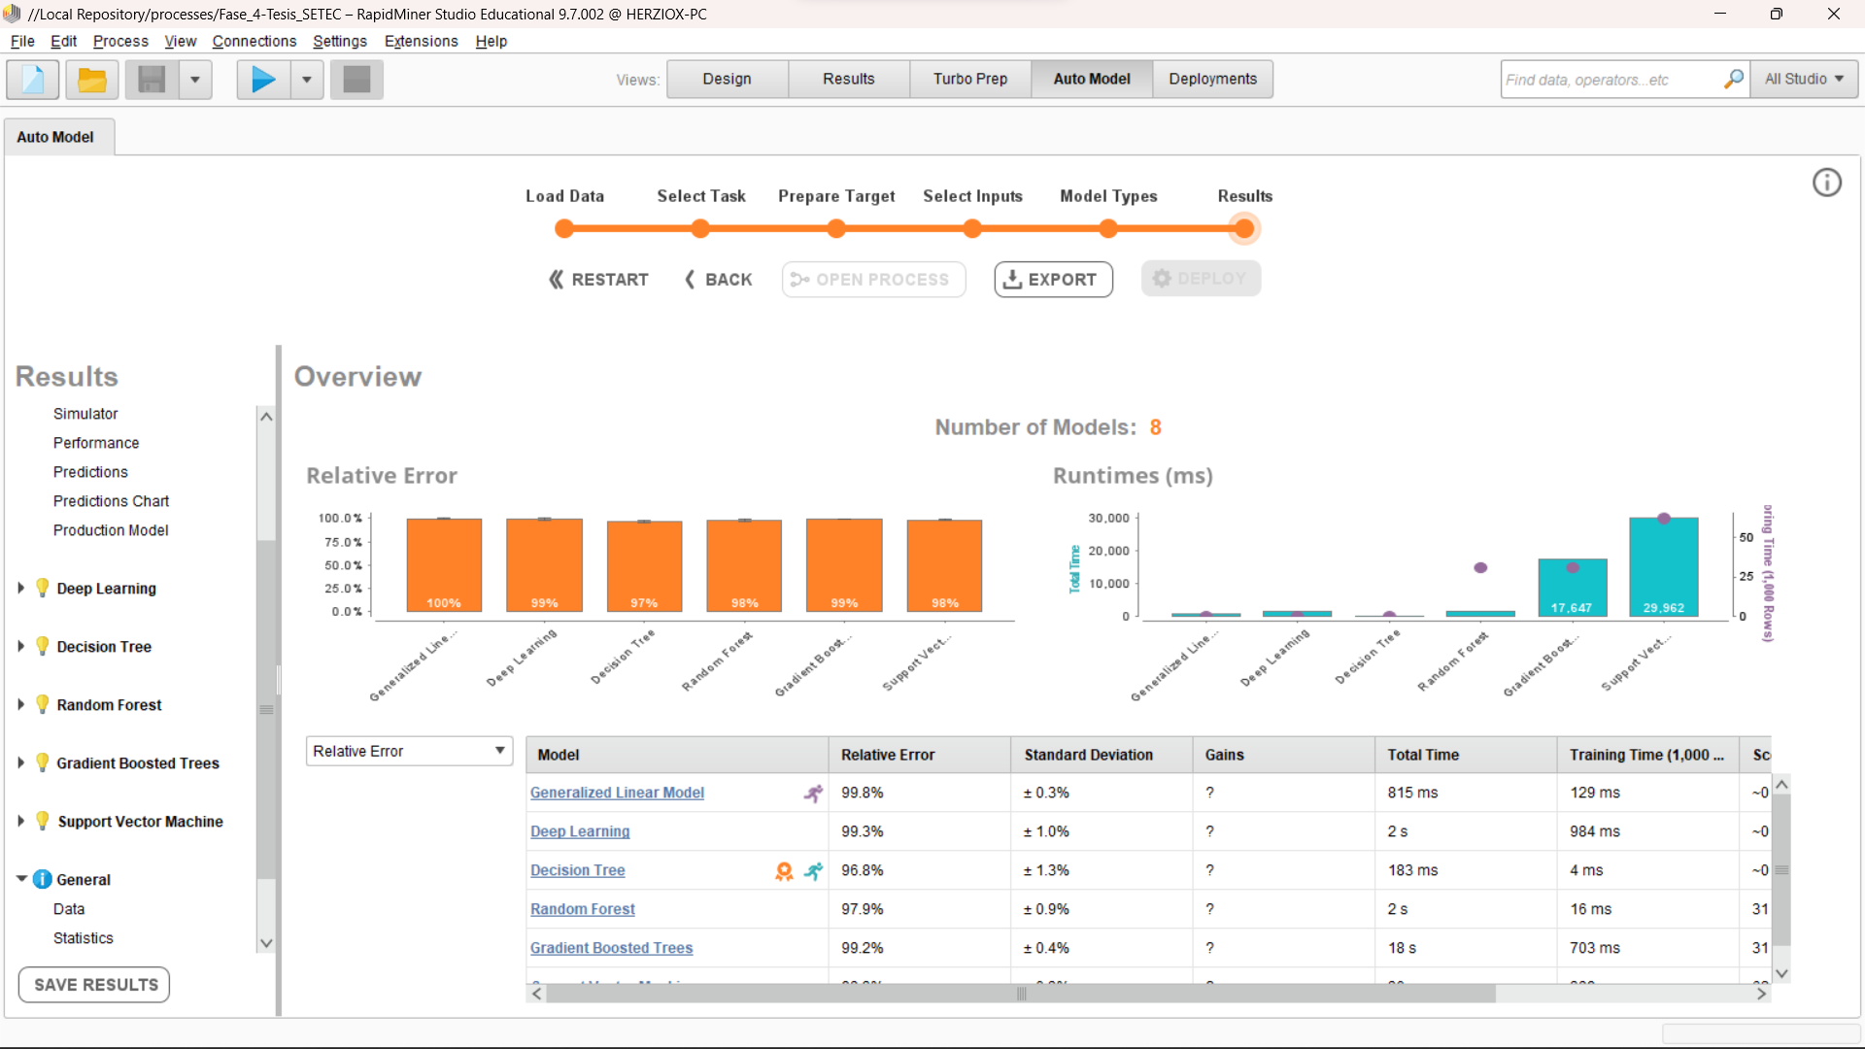

## OEC num_cer

## OEC total_horas

## OEC total_gananias

## OEC porcentaje_asistencia

## OEC volumen_cer

## OEC volumen_horas

## OEC volumen_ganancias

## OEC total_perfiles

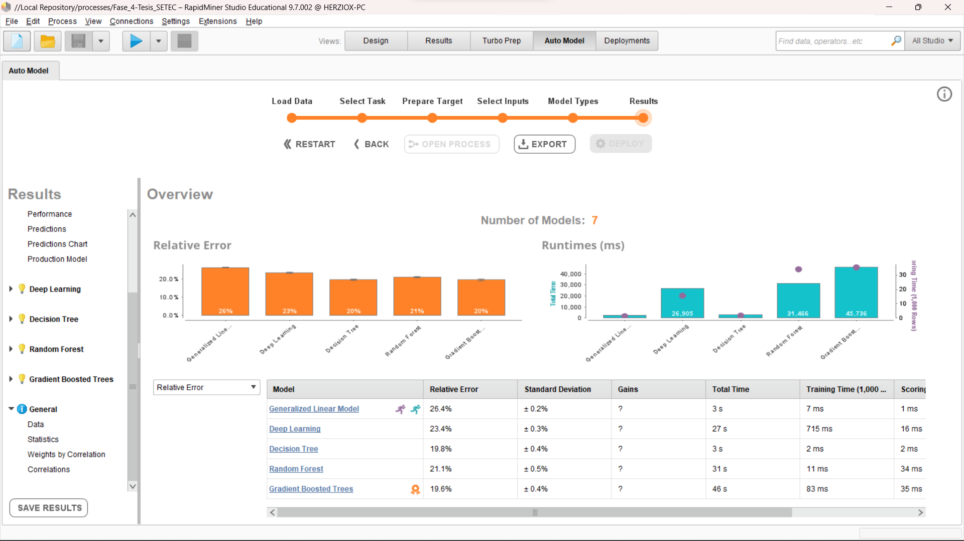

## OEC volumen_porcentaje_asistencia

